library(ggplot2)  
library(dplyr)

Read files

train_bike<-read.csv('train.csv')  
test_bike<-read.csv('test.csv')

Number of column should be same in train and test. Our target is to find total count which is registered+casual. So we can build Model to find count directly insted of finding registered+casual.

Remove registered and causal from training set and then Add count column in test and combine both datasets.

test_bike$count<-NA  
  
train_bike<-select(train_bike,-registered,-casual)  
  
bike<-rbind(train_bike,test_bike)

DateTime VS Count

class(bike$datetime)

## [1] "factor"

bike$datetime<-as.POSIXct(bike$datetime)  
  
class(bike$datetime)

## [1] "POSIXct" "POSIXt"

ggplot(bike,aes(datetime,count))+geom_point(aes(color=temp),alpha=0.3)+scale_color_continuous(low = 'yellow',high = 'red')+theme_bw()

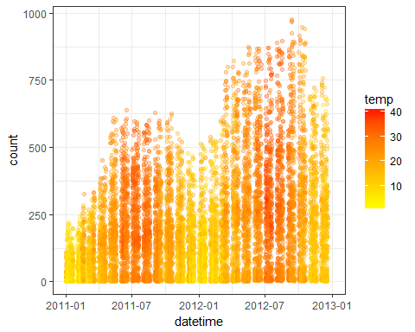 We can see,over the time demand is incresing so linear model is not fit for such data.

Working day vs Demand

bike$hour <-sapply(bike$datetime,function(x){format(x,"%H")})  
  
  
  
ggplot(filter(bike,workingday==1),aes(hour,count))+geom_point(aes(color=temp),position = position_jitter(width = 1,height = 0),alpha=0.5)+scale_color_gradientn(colours = c('dark blue','blue','light blue','light green','yellow','orange','red'))+theme_bw()

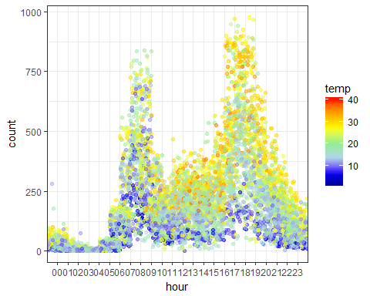 Peak hour:6-9 ,12-15,16-19

class(bike$hour) #Character

## [1] "character"

bike$hour<-as.numeric(bike$hour)  
  
bike$daypart<-0  
  
bike$daypart[bike$hour>=6 & bike$hour<=9]<-1  
bike$daypart[bike$hour>=12 & bike$hour<=15]<-1  
bike$daypart[bike$hour>=16 & bike$hour<=19]<-1  
  
bike$daypart<-as.factor(bike$daypart)

holiday vs Demand

ggplot(filter(bike,workingday==0),aes(hour,count))+geom_point(aes(color=temp),position = position_jitter(width = 1,height = 0),alpha=0.5)+scale_color_gradientn(colours = c('dark blue','blue','light blue','light green','yellow','orange','red'))+theme_bw()

## Warning: Removed 2040 rows containing missing values (geom_point).

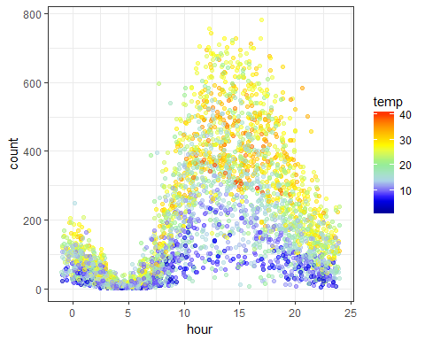

weekday VS Demand

bike$weekday<-weekdays(as.Date(bike$datetime))  
  
  
ggplot(bike,aes(windspeed,count))+geom_point()

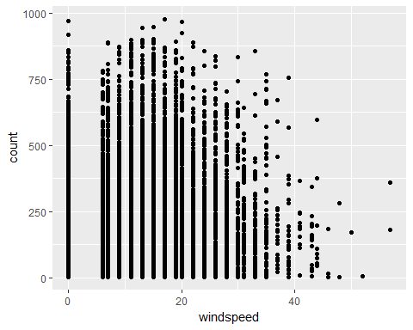

bike$season<-as.factor(bike$season)  
bike$holiday<-as.factor(bike$holiday)  
bike$workingday<-as.factor(bike$workingday)  
bike$weather<-as.factor(bike$weather)  
bike$hour<-as.factor(bike$hour)

Splitting Dataset

#bike<-select(bike,c(-datetime,-hour))  
test<-filter(bike,is.na(count))  
train<-filter(bike,!is.na(count))

xgBoost

#install.packages('xgboost')  
#library(xgboost)  
  
#xgboost dont work with factors. It needs only numeric variables.  
  
#classifier<-xgboost(data=as.matrix(select(train,c(-datetime,-hour,-weekday,-count))),label = train$count,nrounds=2000 )  
  
#pred<-predict(classifier,newdata = as.matrix(select(train,c(-datetime,-hour,-weekday,-count))))

RandomForest

library(randomForest)

## randomForest 4.6-12

## Type rfNews() to see new features/changes/bug fixes.

##   
## Attaching package: 'randomForest'

## The following object is masked from 'package:dplyr':  
##   
## combine

## The following object is masked from 'package:ggplot2':  
##   
## margin

rf_classifier<-randomForest(count~season+holiday+workingday+weather+temp+atemp+humidity+windspeed+daypart,data = train,ntree=50)  
  
rf_pred<-predict(rf_classifier,test)

Kaggle submission file

#s<-data.frame(datetime=test$datetime,count=rf_pred)  
#write.csv(s,file="bike_solution.csv",row.names=FALSE)